Hardware devices use the format hw:i,j, where i is the card number and j is the device on that card. The first sound device is hw:0,0.

A sound card has a hardware buffer that stores recorded samples. When the buffer is sufficiently full, it generates an interrupt. The kernel sound driver then uses direct memory access (DMA) to transfer samples to an application buffer in memory. Similarly, for playback, another application buffer is transferred from memory to the sound card's hardware buffer using DMA.

These hardware buffers are ring buffers, meaning the data wraps back to the start when the end of the buffer is reached. A pointer is maintained to keep track of the current positions in both the hardware buffer and the application buffer.

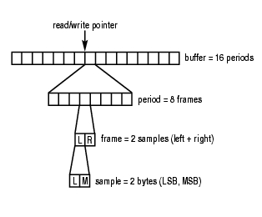
The buffer can be quite large, and transferring it in one operation could result in unacceptable delays, called latency. To solve this, ALSA splits the buffer up into a series of periods (called fragments in OSS/Free) and transfers the data in units of a period.

if the application does not read the data in the buffer rapidly enough, the circular buffer is overwritten with new data. The resulting data loss is known as overrun. During playback, if the application does not pass data into the buffer quickly enough, it becomes starved for data, resulting in an error called underrun.

Pseudo Code
:
open interface for capture or playback
set hardware parameters
(access mode, data format, channels, rate, etc.)
while there is data to be processed:
read PCM data (capture)
or write PCM data (playback)
close interface

